EXPT NO:7 | OVER-PLOTTING REDUCTION TECHNIQUES
DATE: 09.02.2026

PRE-LAB QUESTIONS
- Why is over-plotting common in big data visualization?
Because millions of data points are plotted in limited screen space, causing points to overlap and hide patterns.
- How does data density affect perception?
High density creates dark clusters that dominate attention, while sparse areas may be overlooked, leading to biased interpretation.
- What trade-offs exist between detail and clarity?
Showing all data preserves detail but reduces readability; summarizing data improves clarity but may hide rare or important patterns.
- How do AI datasets increase visualization complexity?
AI datasets are large, high-dimensional, and continuous, making direct plotting cluttered and harder to interpret.
- Why is over-plotting a serious analytical risk?
It can conceal trends, outliers, and relationships, leading to incorrect conclusions and poor decision-making.

OBJECTIVE : To apply techniques that reduce visual clutter in large-scale datasets.

SCENARIO A social media analytics company visualizes millions of user interactions to study engagement patterns.

IN-LAB TASKS (Using R Language) • Apply alpha blending • Implement jittering techniques • Use aggregation and binning

CODE:
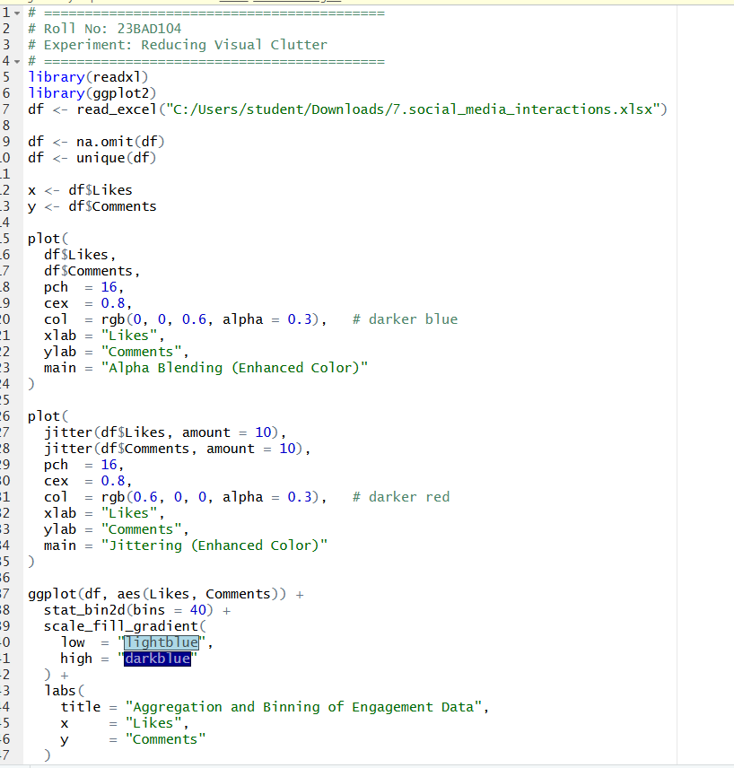

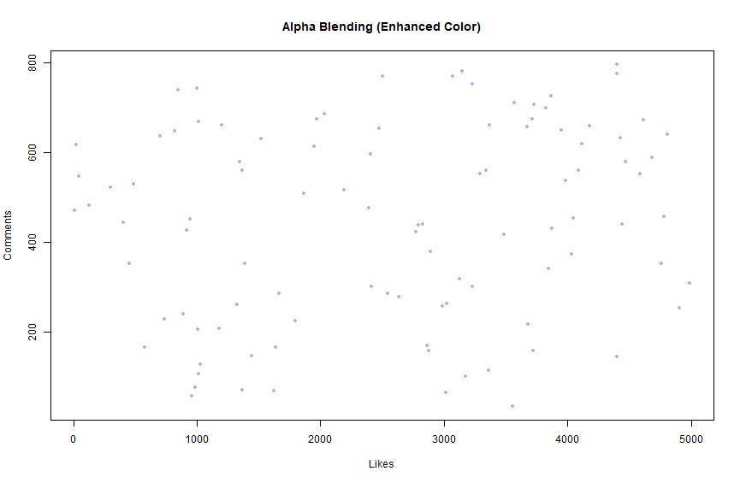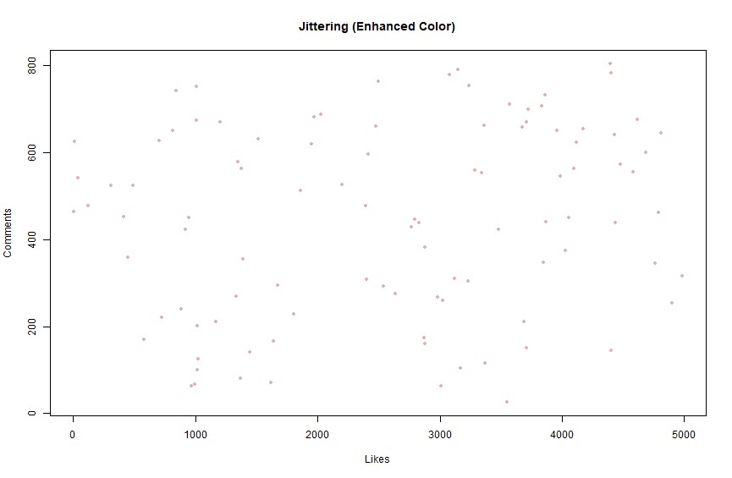

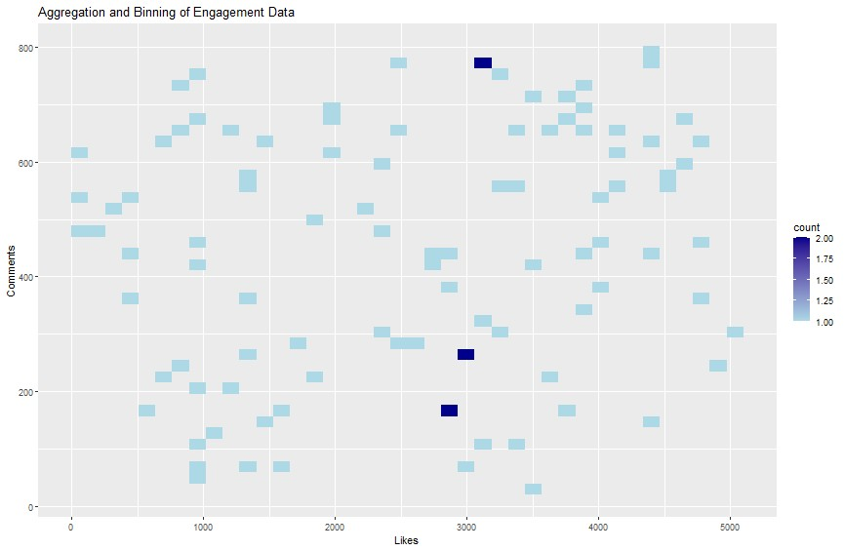

POST-LAB QUESTIONS
- Which technique provided the best clarity and why?
Aggregation and binning gave the best clarity because they summarize millions of points into density regions, revealing overall engagement patterns clearly.
- How does over-plotting distort analytical conclusions?
It hides true data distribution, masks clusters and outliers, and can falsely suggest uniform or misleading trends.
- When should aggregation be preferred over raw plotting?
When datasets are very large or dense and individual points overlap excessively, making raw plots unreadable.
- How do these techniques support scalable AI analytics?
They enable efficient visualization of massive AI datasets by preserving patterns while reducing noise and computational load.
- Explain real-world consequences of ignoring over-plotting.
Misinterpreting user behavior, incorrect model insights, poor business decisions, and flawed AI-driven recommendations can result.

ASSESSMENT

Description |  | Max Marks | Marks Awarded
Pre Lab Exercise |  | 5
In Lab Exercise |  | 10
Post Lab Exercise |  | 5
Viva |  | 10
 | Total | 30
 | Faculty Signature

